Build Deployment Procedure

Schindler CRD Applications

Exported on 2025-08-19 06:01:48

Table of Contents

1 Introduction 4

2 Purpose & Scope 5

3 Pre-Deployment Steps 6

4 BIF Package Deployment 12

5 Update/Verify Site.xconf 32

6 Deploy action model 34

7 Update/Verify Environment Specific Properties 35

8 Increase Column length to 4000 39

9 Post Upgrade Steps 42

9.1 Create JMS Service 42

9.2 Update SchindlerCMSArbortextPublishRules 44

9.3 Update SchindlerCMSArbortextPublishRules - SC7 Product 46

9.4 Update SchindlerCMSTranslationPublishRules 48

9.5 Update Translation Preferences 51

9.6 Create AdHocAccessReport Task delegate 53

9.7 Update Sync on CA Complete robot to use Object Event 54

* Introduction
* Purpose & Scope
* Pre-Deployment Steps
* BIF Package Deployment
* Update/Verify Site.xconf
* Deploy action model
* Update/Verify Environment Specific Properties
* Increase Column length to 4000
* Post Upgrade Steps
  + Create JMS Service
  + Update SchindlerCMSArbortextPublishRules
  + Update SchindlerCMSArbortextPublishRules - SC7 Product
  + Update SchindlerCMSTranslationPublishRules
  + Update Translation Preferences
  + Create AdHocAccessReport Task delegate
  + Update Sync on CA Complete robot to use Object Event

# Introduction

Schindler uses Windchill 12.0.2.11 as their PLM system. Schindler have requested Plural Technology to upgrade their existing Windchill version to Windchill 13.0.2.5  
Plural technologies Windchill Solution Architect had series of discussions and system visits to understand current architecture, usage and existing issues.

# Purpose & Scope

This document captures code porting and deployment of code from source Windchill 12.0.2.11 system to target Windchill 13.0.2.5 system using BIF deployment along with all the post deployment steps.

# Pre-Deployment Steps

* Start DS, HTTP and Windchill on target system

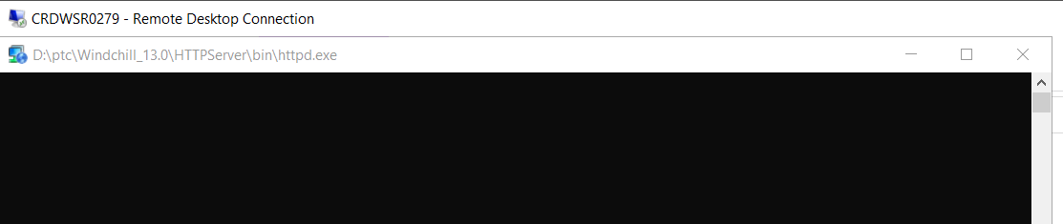

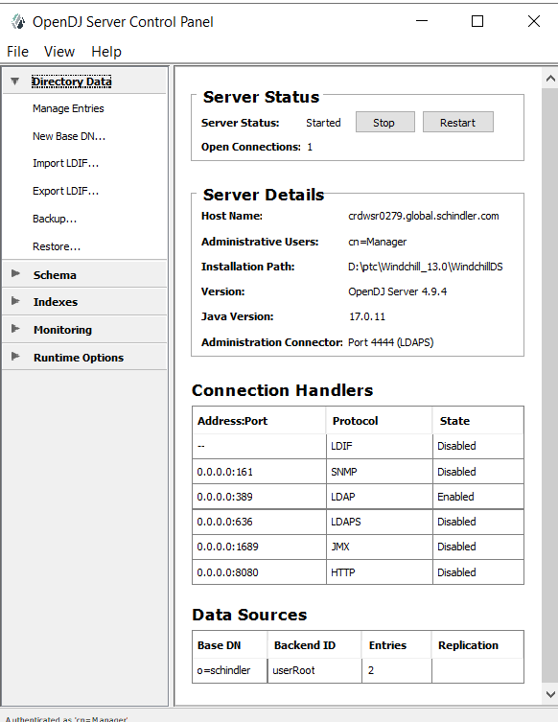

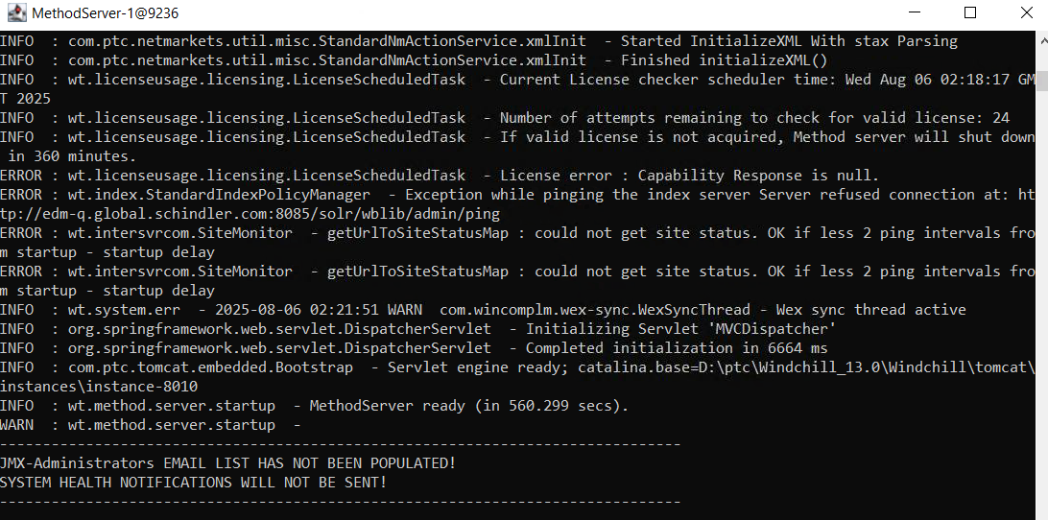

* Set Below Environment variables on target system

*WT_HOME and ANT_HOME*

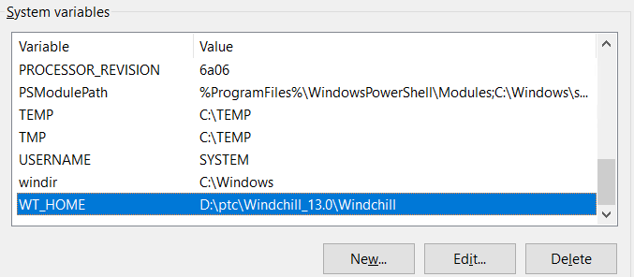

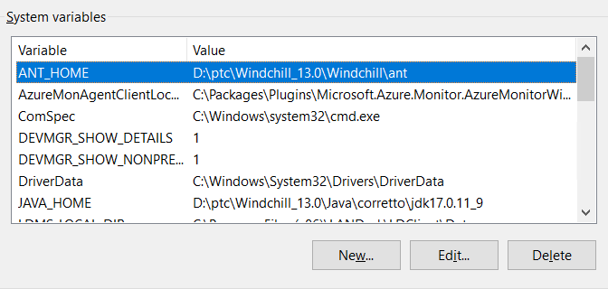

* Create Directory *D:/BitBucket_branches* on target system

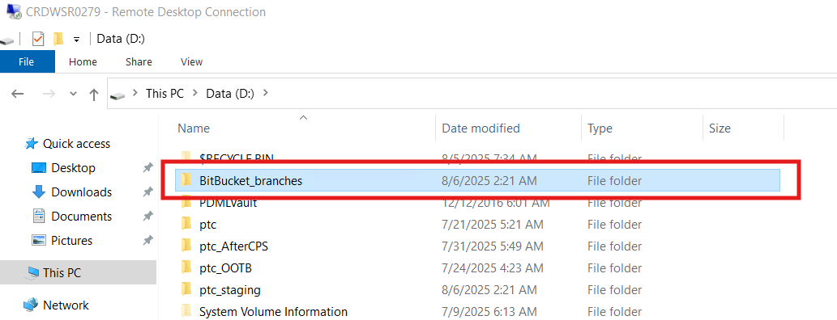

* Copy edm-windchill-master.zip to ptc_staging

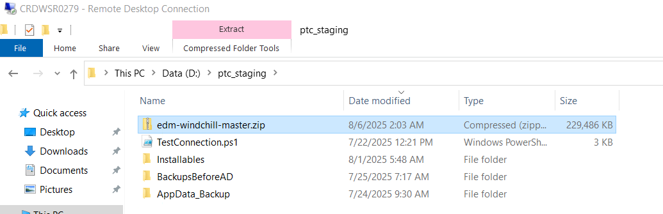

* Extract edm-windchill-master.zip in newly created directory *D:/BitBucket_branches*, it should have folder structure as shown in below screen shot.

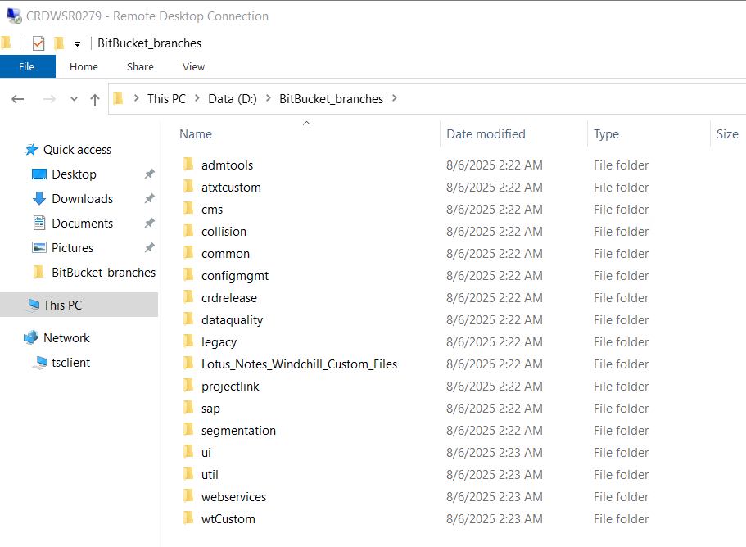

* Validate number of files and folder size

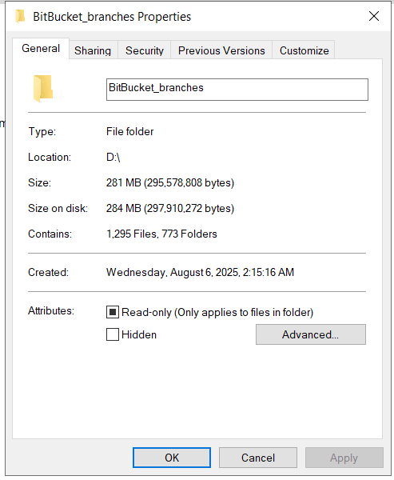

# BIF Package Deployment

* Open Command shell in Admin and navigate to location "D:\BitBucket_branches\util" and run below command

***java -jar srclib\BIFSDK-2.1.1.02.jar dist***

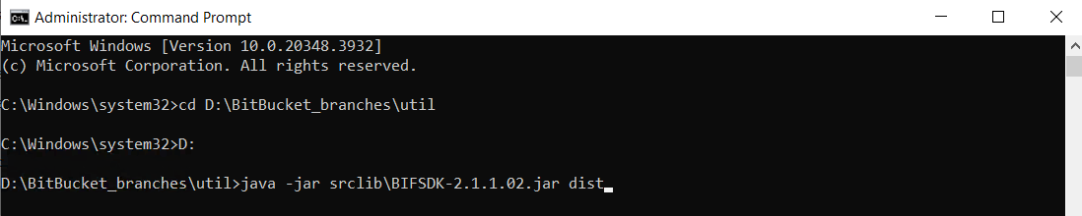

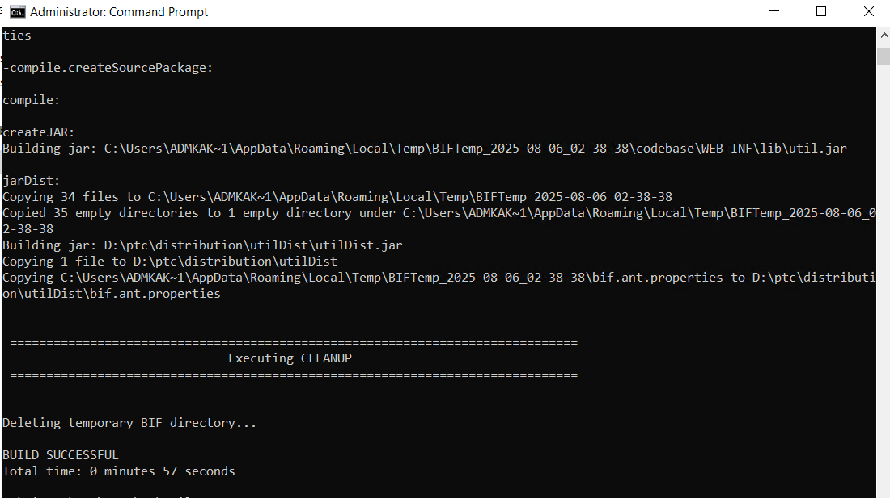

***java -jar D:\ptc\distributionutilDistutilDist.jar install***

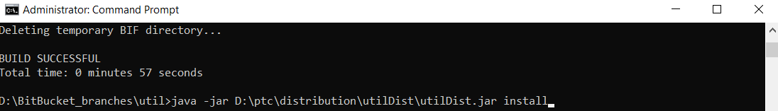

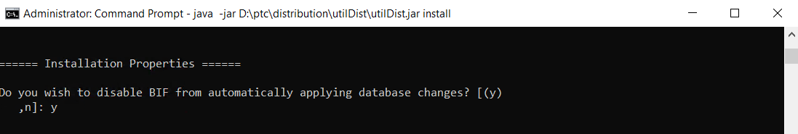

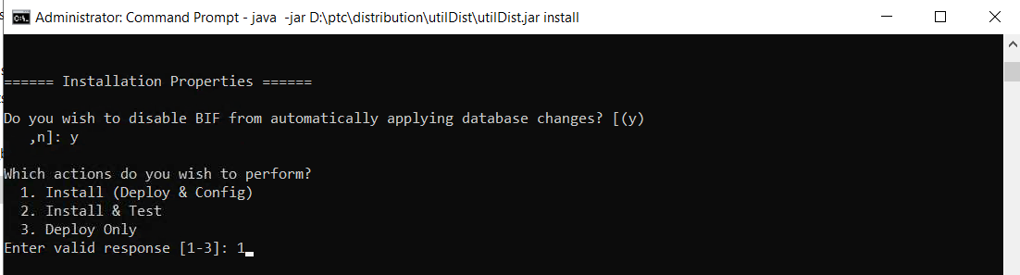

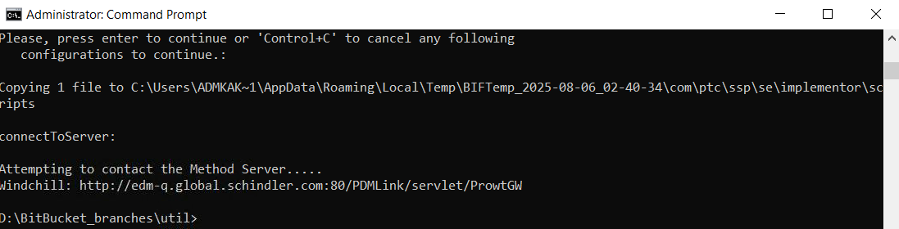

* Open Command shell and navigate to location "D:\BitBucket_branches\ui" and run below command

***java -jar srclib\BIFSDK-2.1.1.02.jar dist***

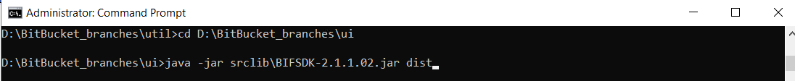

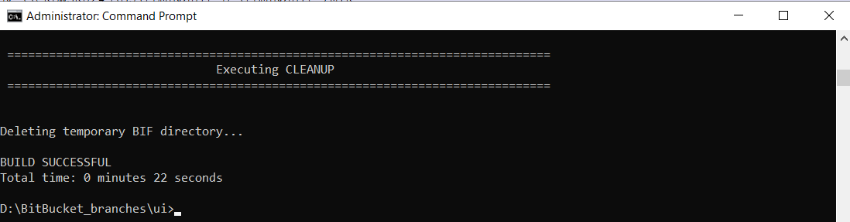

***java -jar D:\ptc\distributionuiDistuiDist.jar install***

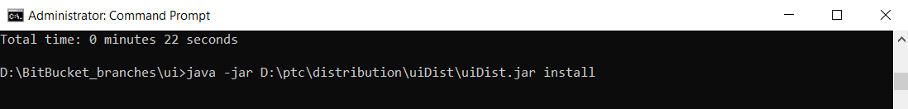

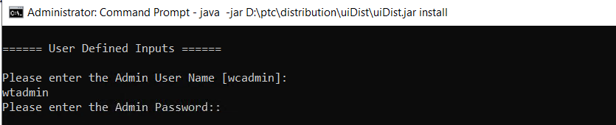

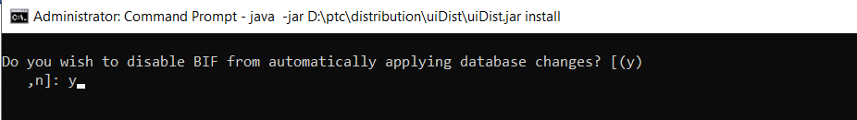

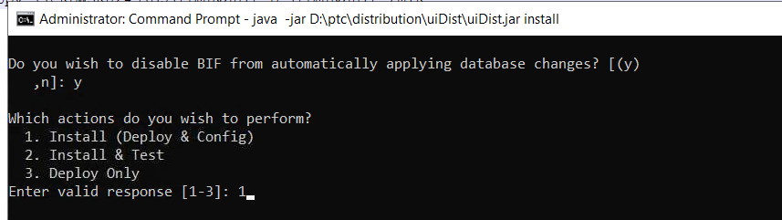

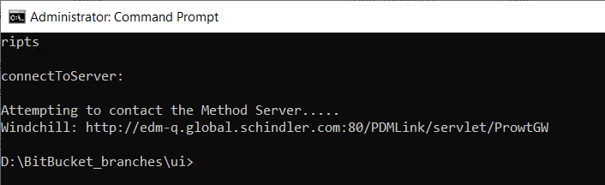

* Open Command shell and navigate to location "D:\BitBucket_branches\projectlink" and run below command

***java -jar srclib\BIFSDK-2.1.1.02.jar dist***

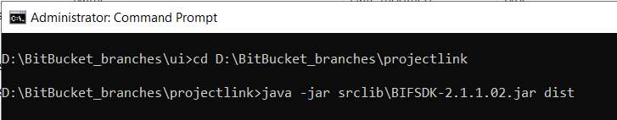

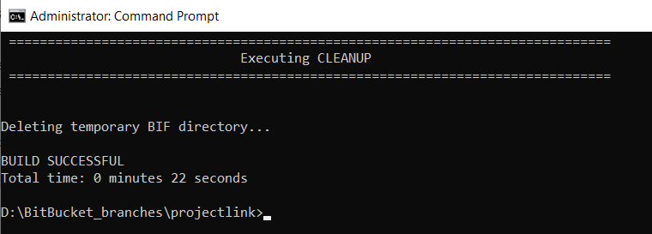

***java -jar D:\ptc\distributionprojectlinkDistprojectlinkDist.jar install***



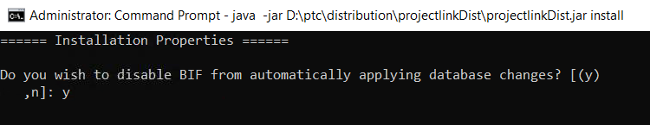

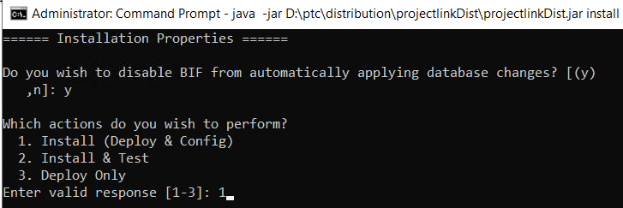

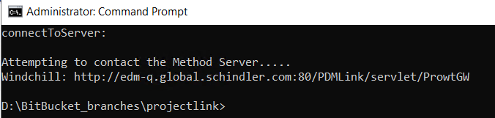

* Open Command shell and navigate to location "D:\BitBucket_branches\dataquality" and run below command

***java -jar srclib\BIFSDK-2.1.1.02.jar dist***

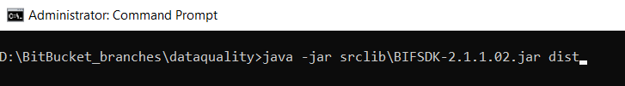

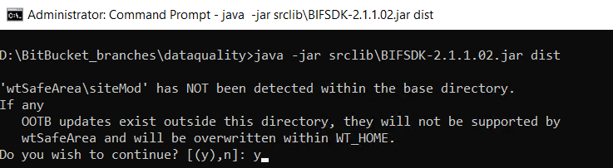

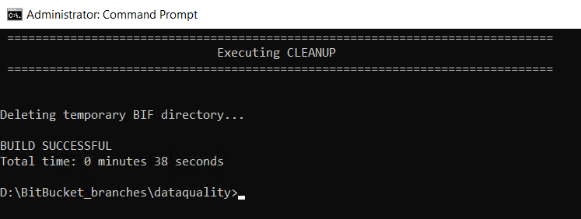

***java -jar D:\ptc\distributiondatqualityDistdataqualityDist.jar install***



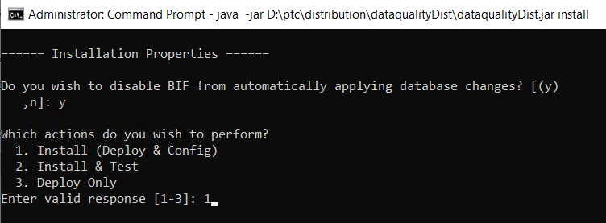

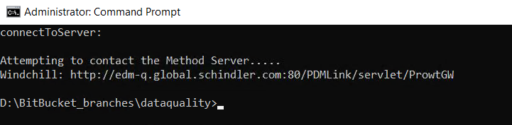

* Open Command shell and navigate to location "D:\BitBucket_branches\webservices" and run below command  
  ***java -jar srclib\BIFSDK-2.1.1.02.jar dist***

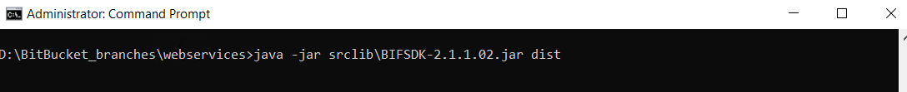

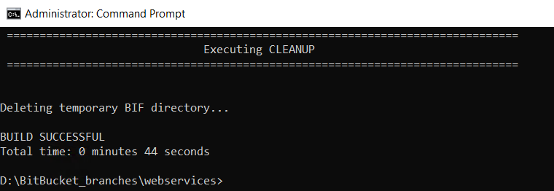

***java -jar D:\ptc\distribution\webservicesDist\webservicesDist.jar install***

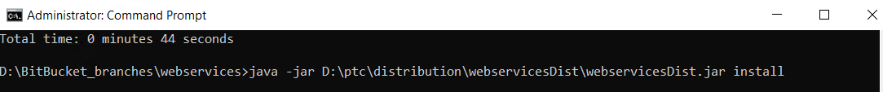

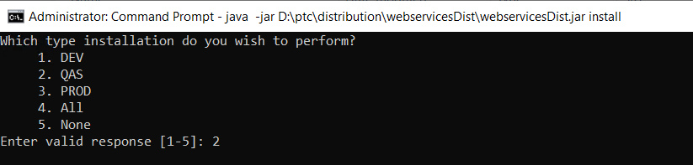

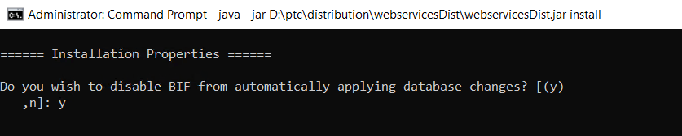

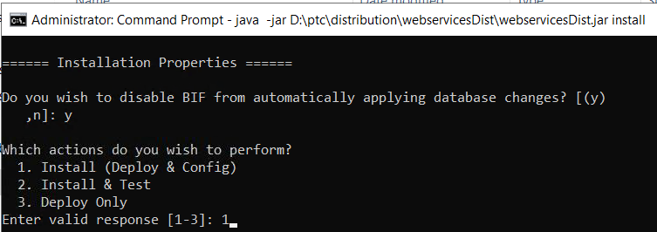

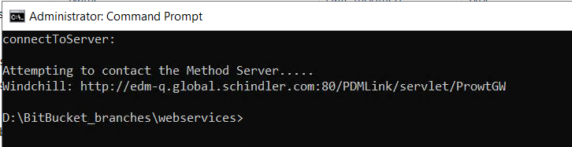

* Open Command shell and navigate to location “D:\BitBucket_branches\ segmentation” and run below command

*java -jar srclib\BIFSDK-2.1.1.02.jar dist*

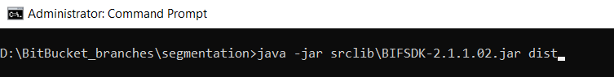

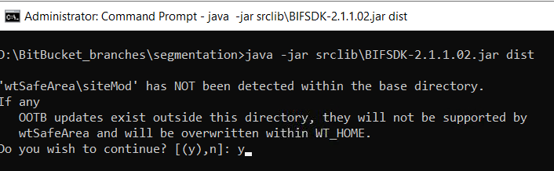

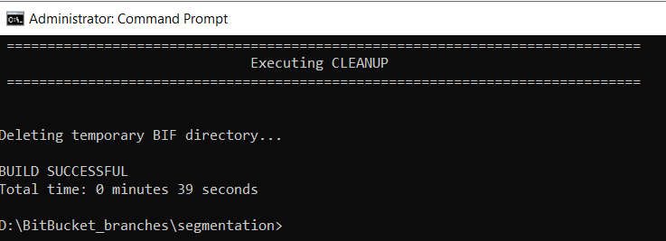

*java -jar D:\ptc\distribution\segmentationDist\segmentationDist.jar install*

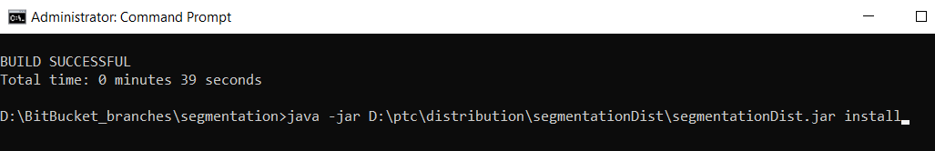

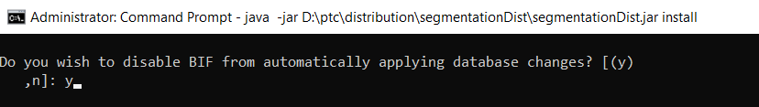

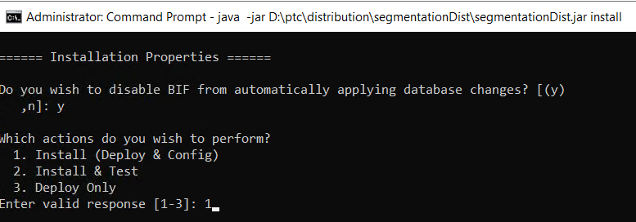

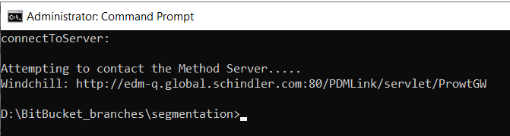

* Open Command shell and navigate to location “D:\BitBucket_branches\ sap” and run below command

*java -jar srclib\BIFSDK-2.1.1.02.jar dist*

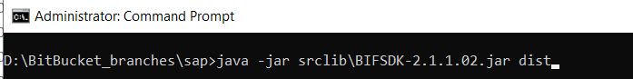

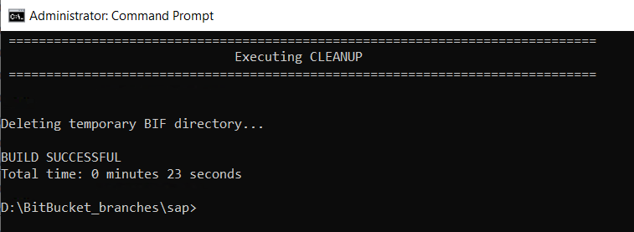

*java -jar D:\ptc\distribution\sapDist\sapDist.jar install*

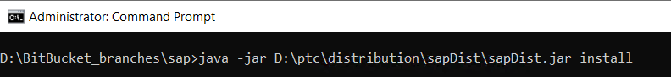

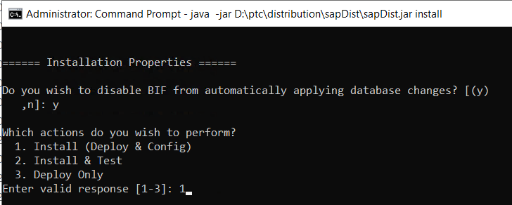

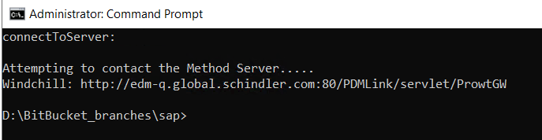

* Open Command shell and navigate to location “D:\BitBucket_branches\ crdrelease” and run below command

*java -jar srclib\BIFSDK-2.1.1.02.jar dist*

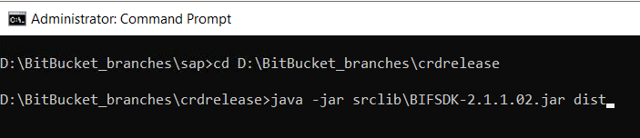

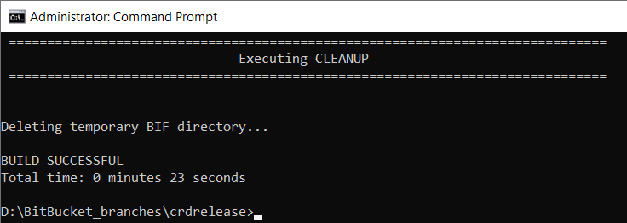

*java -jar D:\ptc\distribution*crdrelease*Dist*crdrelease*Dist.jar install*

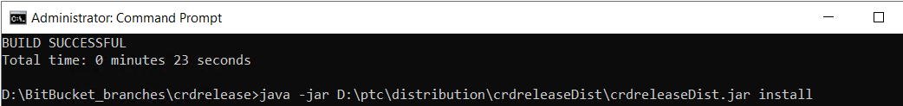

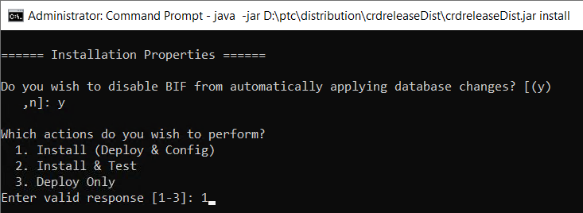

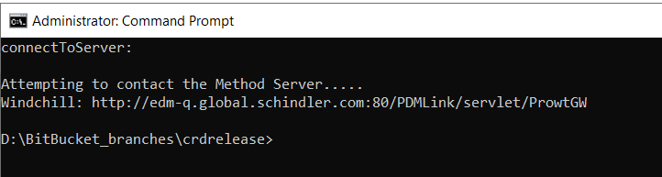

* Open Command shell and navigate to location “D:\BitBucket_branches\admtools” and run below command

*java -jar srclib\BIFSDK-2.1.1.02.jar dist*

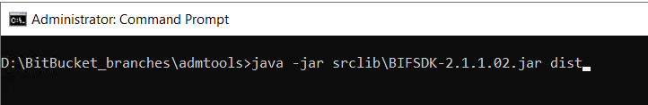

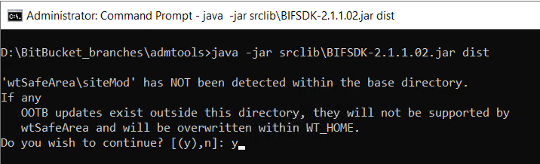

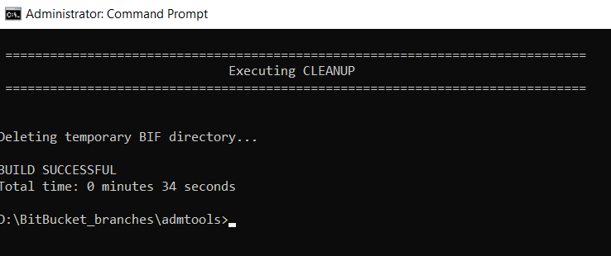

*java -jar D:\ptc\distribution\admtoolsDist\admtoolsDist.jar install*

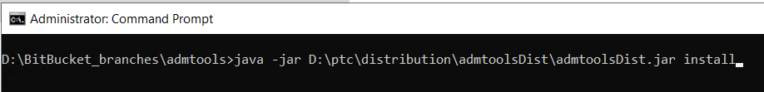

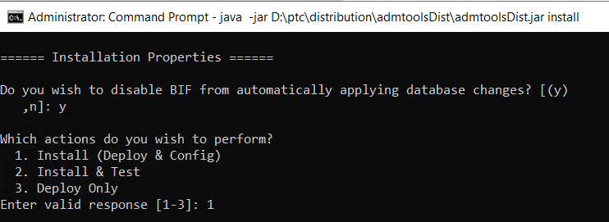

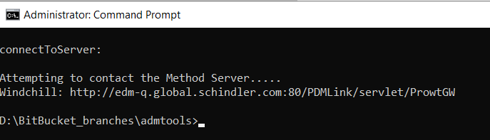

* Open Command shell and navigate to location “D:\BitBucket_branches\ cms” and run below command

*java -jar srclib\BIFSDK-2.1.1.02.jar dist*

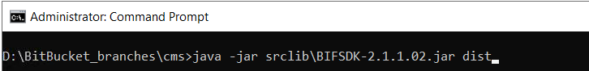

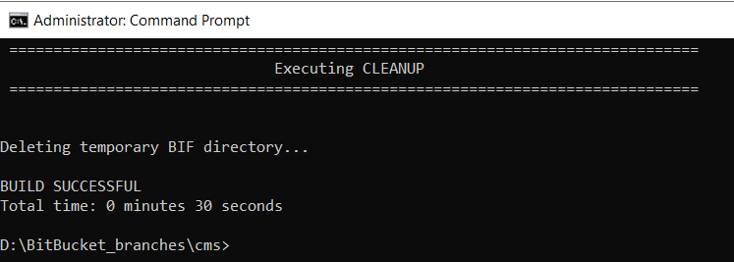

*java -jar D:\ptc\distribution\cmsDist\cmsDist.jar install*

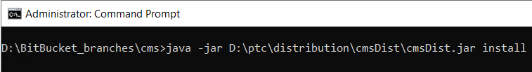

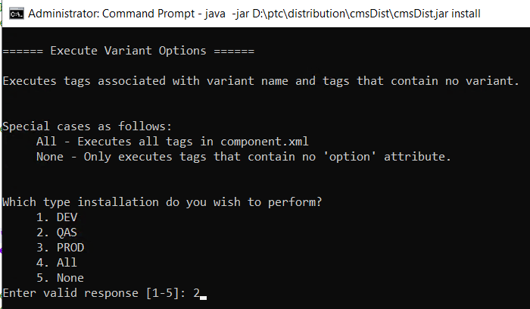

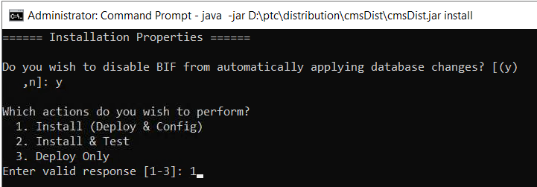

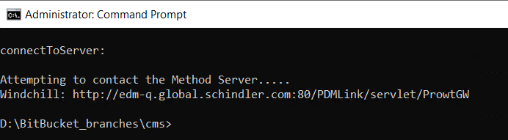

* Open Command shell and navigate to location “D:\BitBucket_branches\ configmgmt” and run below command

*java -jar srclib\BIFSDK-2.1.1.02.jar dist*

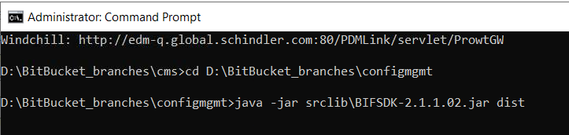

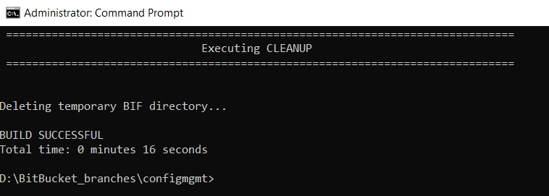

*java -jar D:\ptc\distribution*configmgmt*Dist*configmgmt*Dist.jar install*

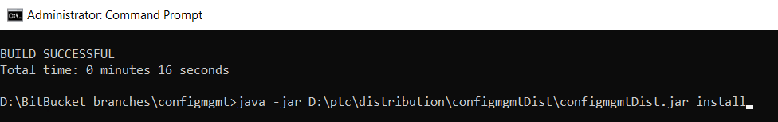

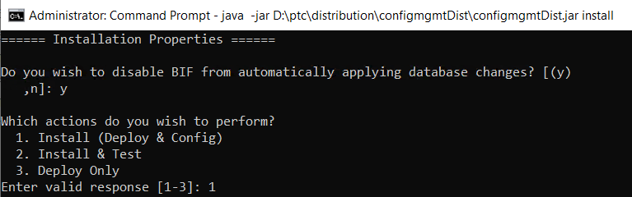

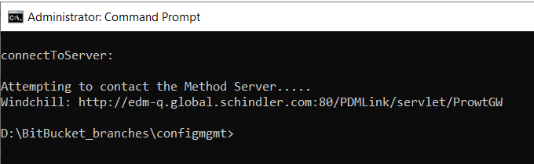

* Open Command shell and navigate to location “D:\BitBucket_branches\collision\collisiondetection” and run below command

*java -jar srclib\BIFSDK-2.1.1.02.jar dist*

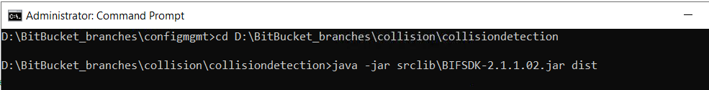

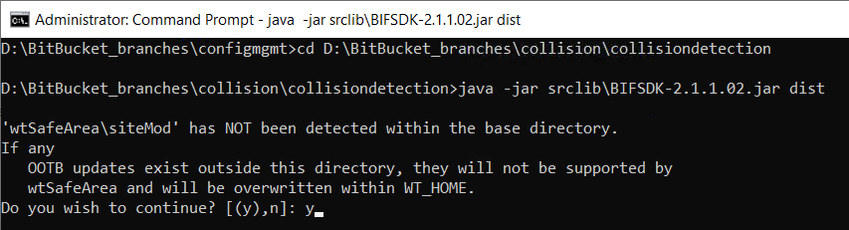

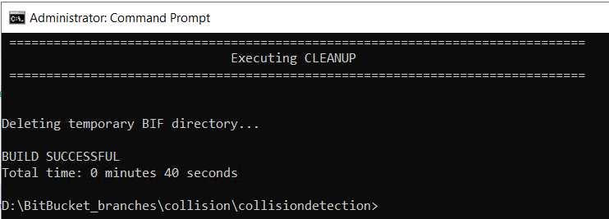

*java -jar D:\ptc\distribution*collision*Dist*collision*Dist.jar install*



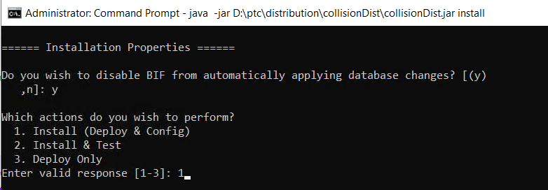

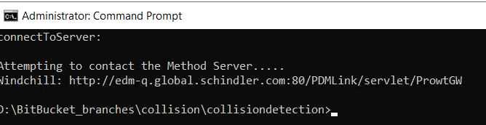

* Open Command shell and navigate to location “D:\BitBucket_branches\common” and run below command

*java -jar srclib\BIFSDK-2.1.1.02.jar dist*

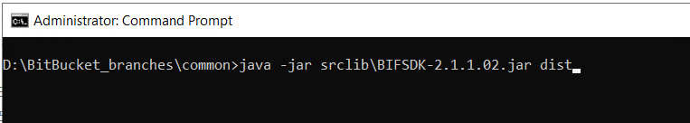

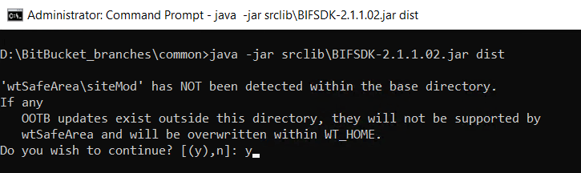

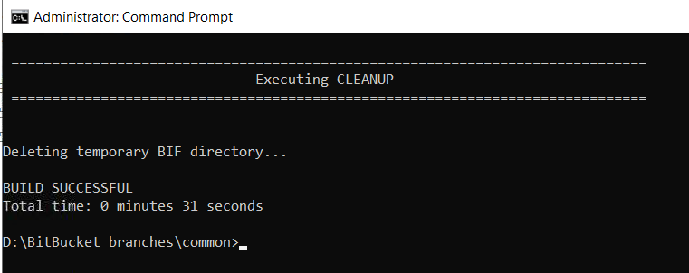

java -jar D:\ptc\distribution\schcommonDist\schcommonDist.jar install

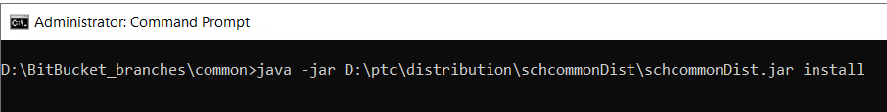

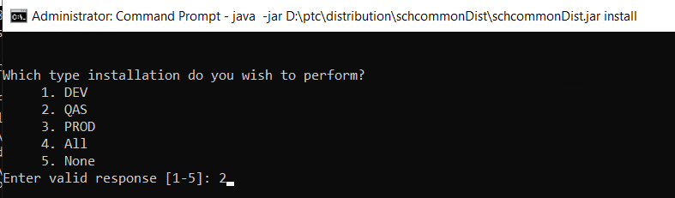

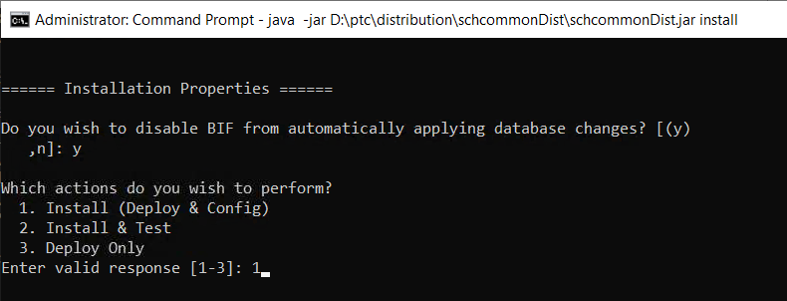

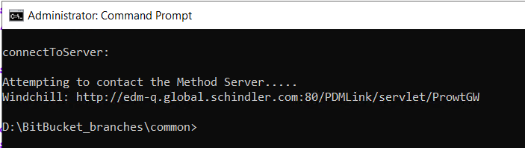

* Open Command shell and navigate to location “D:\BitBucket_branches\Lotus_Notes_Windchill_Custom_Files\Migration_Files\Windchill” and run below command

*java -jar srclib\BIFSDK-2.1.1.02.jar dist*

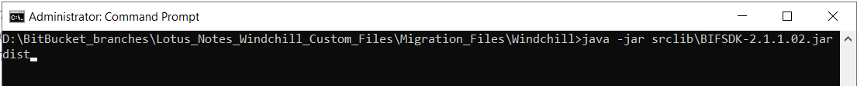

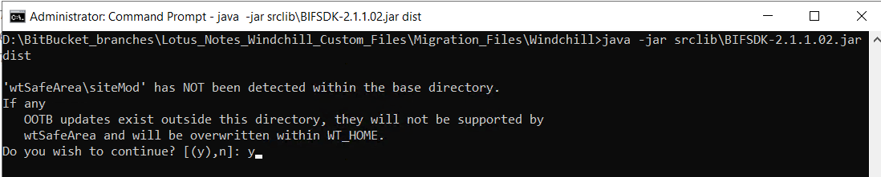

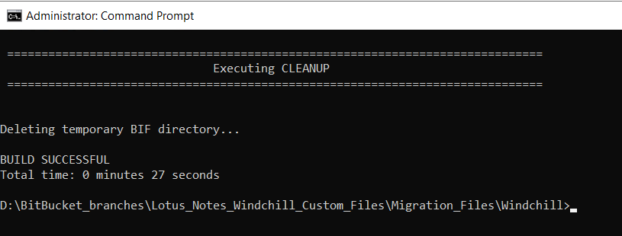

*java -jar D:\ptc\distribution\lotusdocumentDist\lotusdocumentDist.jar install*

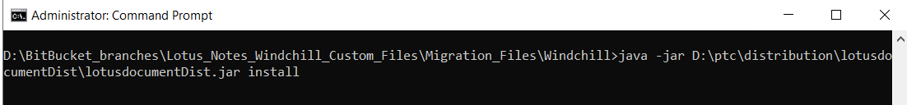

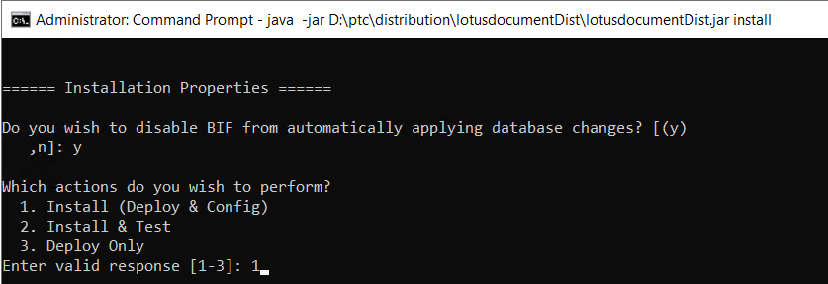

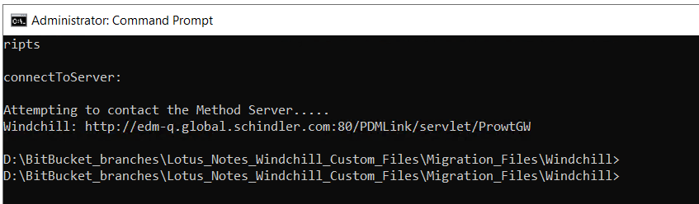

# Update/Verify Site.xconf

* Update below entries in site.xconf

**<Property name="wt.org.initial.uniquenesslevel" overridable="true"**  
**targetFile="codebase/wt.properties"**  
**value="SITE_LEVEL"/>**

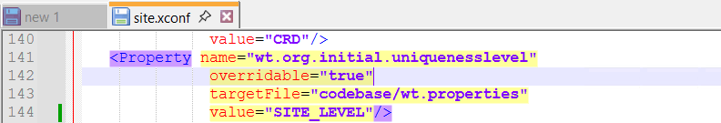

* verify below entries in site.xconf

<ConfigurationRef xlink:href="util.xconf"/>  
<ConfigurationRef xlink:href="ui.xconf"/>  
<ConfigurationRef xlink:href="projectlink.xconf"/>  
<ConfigurationRef xlink:href="webservices_qas.xconf"/>  
<ConfigurationRef xlink:href="sap.xconf"/>  
<ConfigurationRef xlink:href="crdrelease.xconf"/>  
<ConfigurationRef xlink:href="cms_qas.xconf"/>  
<ConfigurationRef xlink:href="configmgt.xconf"/>  
<ConfigurationRef xlink:href="schindler.xconf"/>

<ConfigurationRef xlink:href="performance_qas.xconf"/>  
<ConfigurationRef xlink:href="customXconf/lotusNotesEntry.xconf "/>

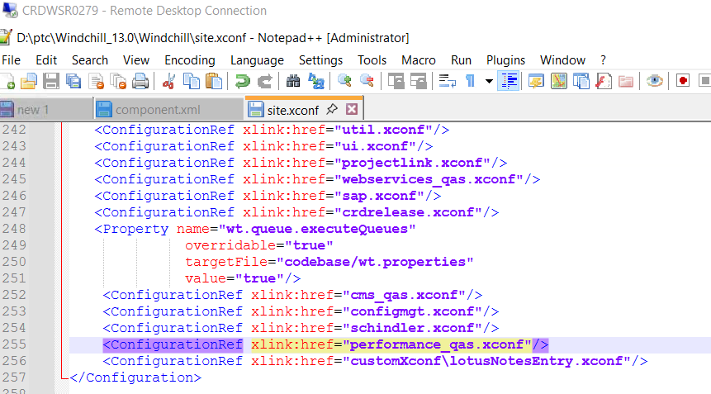

**_dev** is for Development server  
**_qas** is for QA server  
**_prod** is for Production server

* Update wt.mail.from property in schindler.xconf as per below
  1. Dev - [crd_edm_dev@schindler.com](mailto:crd_edm_dev@schindler.com)
  2. QA - [crd_edm_qas@schindler.com](mailto:crd_edm_qas@schindler.com)
  3. PROD - [crd_edm_prod@schindler.com](mailto:crd_edm_prod@schindler.com)

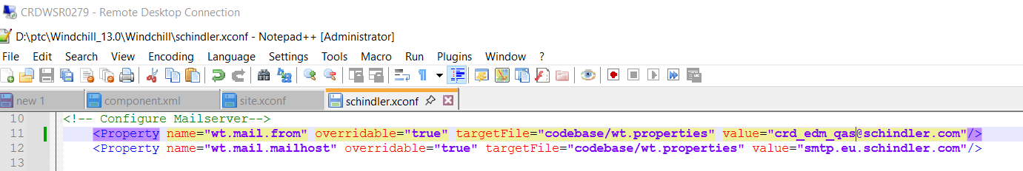

# Deploy action model

* Copy custom-actionModels.xml and custom-actions.xml from  D:\BitBucket_branches\ui\wtSafeArea\siteMod\codebase\config\actions to <WC_HOME>\codebase\config\actions

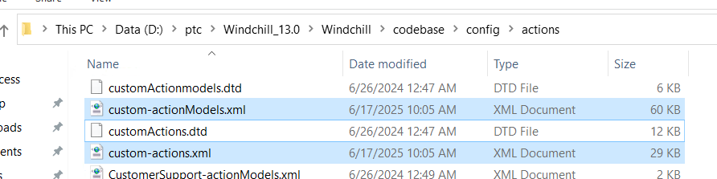

# Update/Verify Environment Specific Properties

* Update <WC_HOME>\codebase\ext\schindler\cms\translation\jms\jms.xconf

|  |  |  |  |  |
| --- | --- | --- | --- | --- |
|  | **Property Name** | **Development** | **QAS** | **Production** |
| 1 | ext.schindler.cms.translation.SftpUsername | windchill | windchill | windchill |
| 2 | ext.schindler.cms.translation.SftpPassword | **<Password>** | **<Password>** | **<Password>** |
| 3 | ext.schindler.cms.translation.SftpHostname | shhlsr0375.dmz2.schindler.com:22 | shhlsr0374.dmz2.schindler.com:22 | shhlsr0376.dmz2.schindler.com:22 |

* Update <WC_HOME>\codebase\ext\schindler\sap\esi\service\content.properties.xconf

|  |  |  |  |  |
| --- | --- | --- | --- | --- |
|  | **Property Name** | **Development** | **QAS** | **Production** |
| 1 | ext.schindler.sap.esi.service.content.ftpRemoteFolder | D_WC_SAP_PDM/FT | Q_WC_SAP_PDM/FT | P_WC_SAP_PDM/FT |
| 2 | ext.schindler.sap.esi.service.content.ftpPort | 21 | 21 | 21 |
| 3 | ext.schindler.sap.esi.service.content.ftpHost | crdftp.schindler.com | shhwsr2496.global.schindler.com | crdftp.schindler.com |
| 4 | ext.schindler.sap.esi.service.content.ftpUser | dwic4ws | qwic4ws | pwic4ws |
| 5 | ext.schindler.sap.esi.service.content.ftpPassword | **<Password>** | **<Password>** | **<Password>** |
| 6 | ext.schindler.sap.esi.service.content.ftpIsSecured | false | false | false |

* Update <WC_HOME>\codebase\ext\schindler\cms\schindler_cms.properties

|  |  |  |  |  |
| --- | --- | --- | --- | --- |
|  | **Property Name** | **Development** | **QAS** | **Production** |
| 1 | ext.ptc.schindler.pnc.webservice.endpointaddress | https\://infwdt31.inf.schindler.com/sap/bc/srt/rfc/sap/ztpzp_ad_dcminf_rdychkin_check/672/ztpzp_ad_dcminf_rdychkin_check/ztpzp_ad_dcminf_rdychkin_checkbinding | https\://infwdc31.inf.schindler.com/sap/bc/srt/rfc/sap/ztpzp_ad_dcminf_rdychkin_check/670/ztpzp_ad_dcminf_rdychkin_check/ztpzp_ad_dcminf_rdychkin_checkbinding | http\://infwdeu1.inf.schindler.com/sap/bc/srt/rfc/sap/ztpzp_ad_dcminf_rdychkin_check/670/ztpzp_ad_dcminf_rdychkin_check/ztpzp_ad_dcminf_rdychkin_checkbinding |
| 2 | ext.ptc.schindler.pnc.webservice.username | DPTCWCPDM | QPTCWCPDM | PPTCWCPDM |
| 3 | ext.ptc.schindler.pnc.webservice.password | **<Password>** | **<Password>** | **<Password>** |

* Update <WC_HOME>\tasks\ext\schindler\cms\translation\jms\sendJmsMessage.xml

|  |  |  |  |  |
| --- | --- | --- | --- | --- |
|  | **Property Name** | **Development** | **QAS** | **Production** |
| 1 | param name="service | <ie:param name="service" data="com.schindler.global.edm-d.jmsService" /> | <ie:param name="service" data="com.schindler.global.edmq.jmsService" /> | <ie:param name="service" data="com.schindler.global.edm.jmsService" /> |

* Update <WC_HOME>\tasks\ext\schindler\cms\translation\jms\ subscribeQueue.xml

|  |  |  |  |  |
| --- | --- | --- | --- | --- |
|  | **Property Name** | **Development** | **QAS** | **Production** |
| 1 | param name="service | <ie:param name="service" data="com.schindler.global.edm-d.jmsService" /> | <ie:param name="service" data="com.schindler.global.edmq.jmsService" /> | <ie:param name="service" data="com.schindler.global.edm.jmsService" /> |

* Update <WC_HOME>\schindler.xconf . Add below values as per each environment

|  |  |  |  |  |
| --- | --- | --- | --- | --- |
|  | **Property Name** | **Development** | **QAS** | **Production** |
| 1 | wt.auth.trustedHosts | [CRDWSR0277.global.schindler.comhttp://CRDWSR0277.global.schindler.com](http://CRDWSR0277.global.schindler.com)[CRDWSR0278.global.schindler.com](http://CRDWSR0278.global.schindler.com)<http://CRDWSR0277.global.schindler.com>[CRDWSR0246.global.schindler.com](http://CRDWSR0246.global.schindler.com) | [CRDWSR0280.global.schindler.com](http://CRDWSR0280.global.schindler.com) [CRDWSR0281.global.schindler.com](http://CRDWSR0281.global.schindler.com) [CRDWSR0277.global.schindler.com](http://CRDWSR0277.global.schindler.com) |  |
| 2 | wt.httpgw.hostname | [dswwsr0012.global.schindler.com](http://dswwsr0012.global.schindler.com), [dswwsr0013.global.schindler.com](http://dswwsr0013.global.schindler.com), [dswwsr0014.global.schindler.com](http://dswwsr0014.global.schindler.com), [dswwsr0015.global.schindler.com](http://dswwsr0015.global.schindler.com) | [DSWWSR0017.global.schindler.com](http://DSWWSR0017.global.schindler.com), [DSWWSR0018.global.schindler.com](http://DSWWSR0018.global.schindler.com), [DSWWSR0019.global.schindler.com](http://DSWWSR0019.global.schindler.com), [SCNWSR1010.global.schindler.com](http://SCNWSR1010.global.schindler.com), [INDWSR0113.global.schindler.com](http://INDWSR0113.global.schindler.com), [INDWSR0114.global.schindler.com](http://INDWSR0114.global.schindler.com), [SAOWSR0027.global.schindler.com](http://SAOWSR0027.global.schindler.com), [SECWSR0021.global.schindler.com](http://SECWSR0021.global.schindler.com) |  |

**Dev Server**

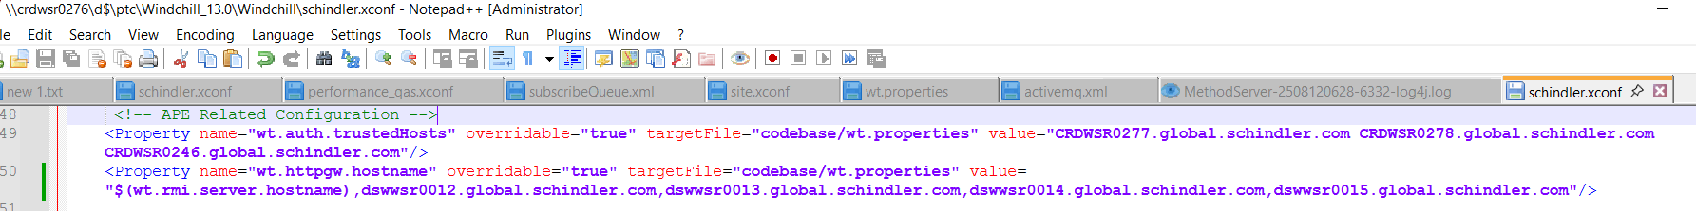

**QA Server**

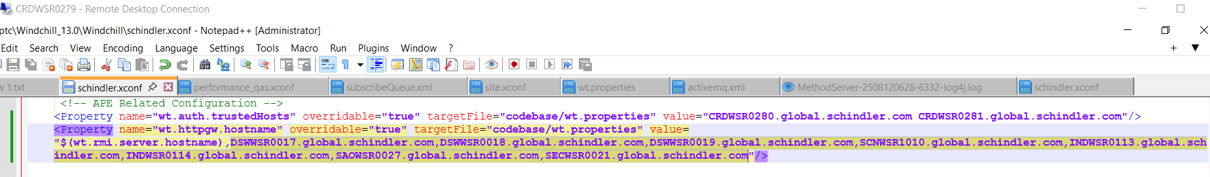

* Run below command from windchill shell:

**ant -f D:\ptc\Windchill_13.0\Windchill\bin\adminTools\sip\EncryptPasswords.xml encryptPw -DpropertyName=ext.schindler.webservices.inventio.auth.password -Dpassword="PASSWORD"**

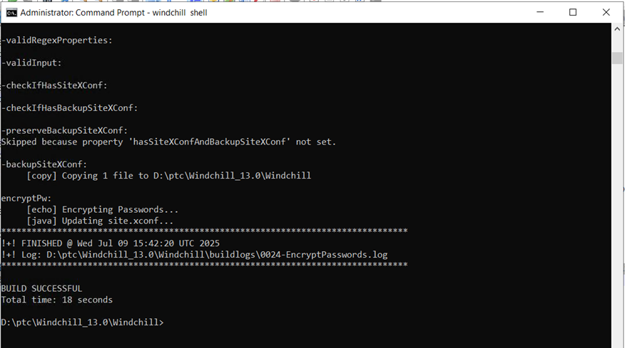

Note: Please refer below table for password in each environment

|  |  |  |  |  |
| --- | --- | --- | --- | --- |
|  | Property Name | Development (DPTCWCPDM) | QAS (QPTCWCPDM) | Production (PPTCWCPDM) |
| 1 | Native data password | **<Password>** | **<Password>** | **<Password>** |

# Increase Column length to 4000

* Set below property before running upgrademanager -cs

xconfmanager -s "wt.db.maxBytesPerChar=1" -t codebase/wt.properties -p

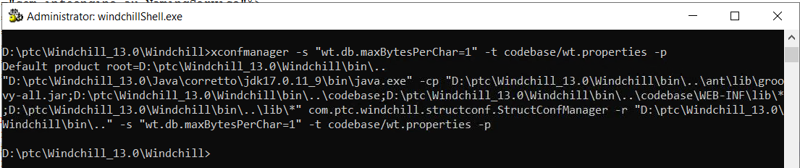

* Validate valueModel.properties is available at below location

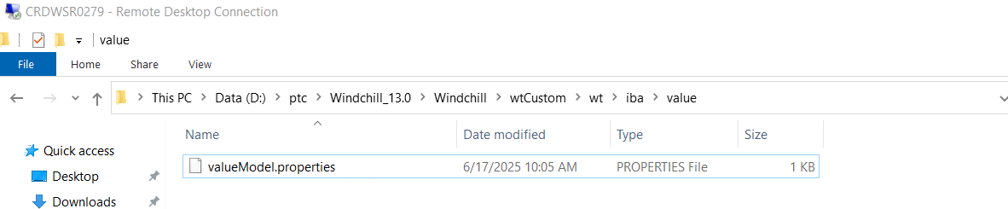

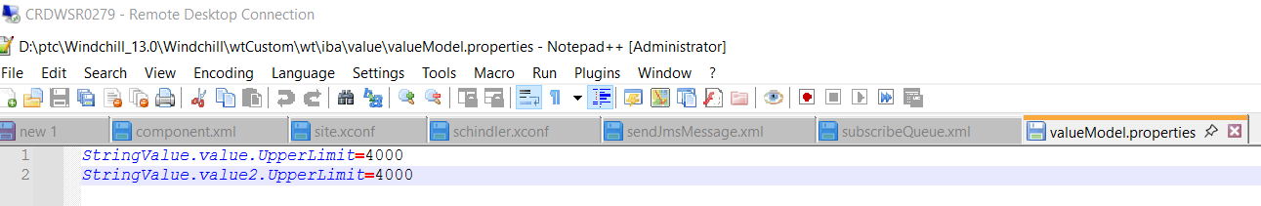

* Execute below command in Windchill Shell to generate class info objects

ant -f bin\tools.xml custom_column -Dgen.input=wt.iba.value

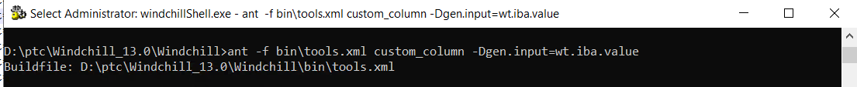

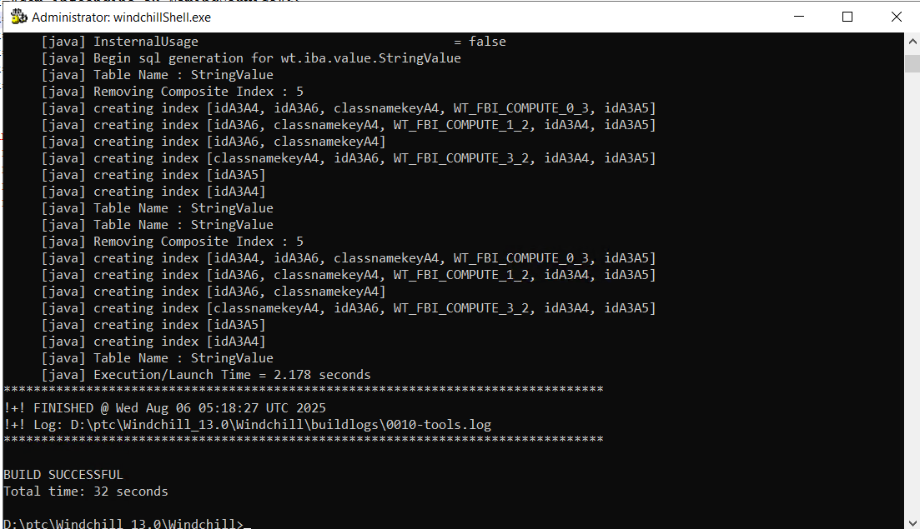

* Run xconfmanager -p from shell

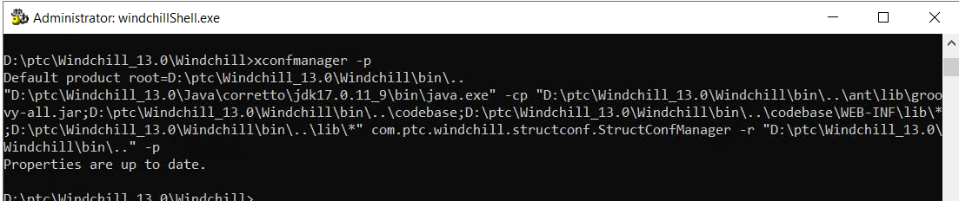

* create java_bm.exe, java_sm.exe and java_ms.exe

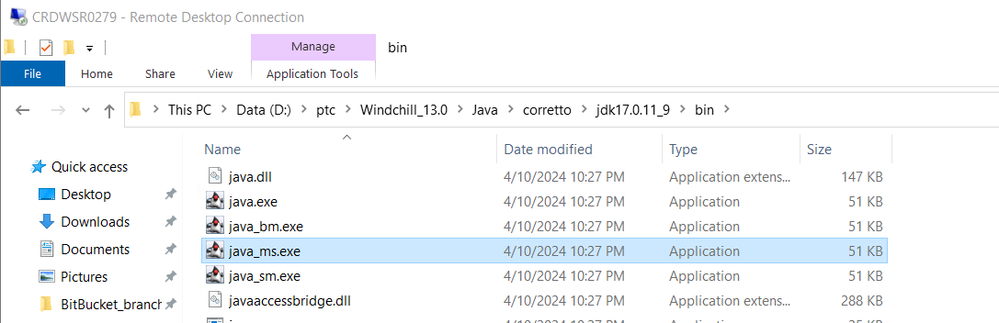

* Take backup of ptc folder and name it is ptc_bkp_afterBuild

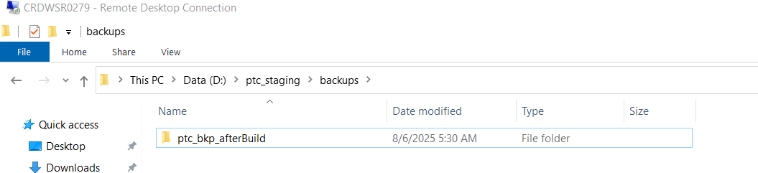

* Restart HTTP, DS and Windchill
* Make sure windchill is up and running.

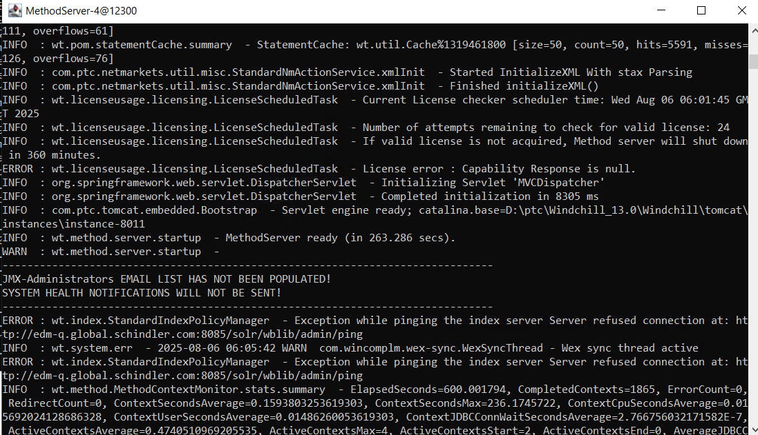

# Post Upgrade Steps

## Create JMS Service

* Login to windchill with site admin access and go to Site > Utilities > Info*Engine Administration and update jms service adapter as shown in below screen shots:

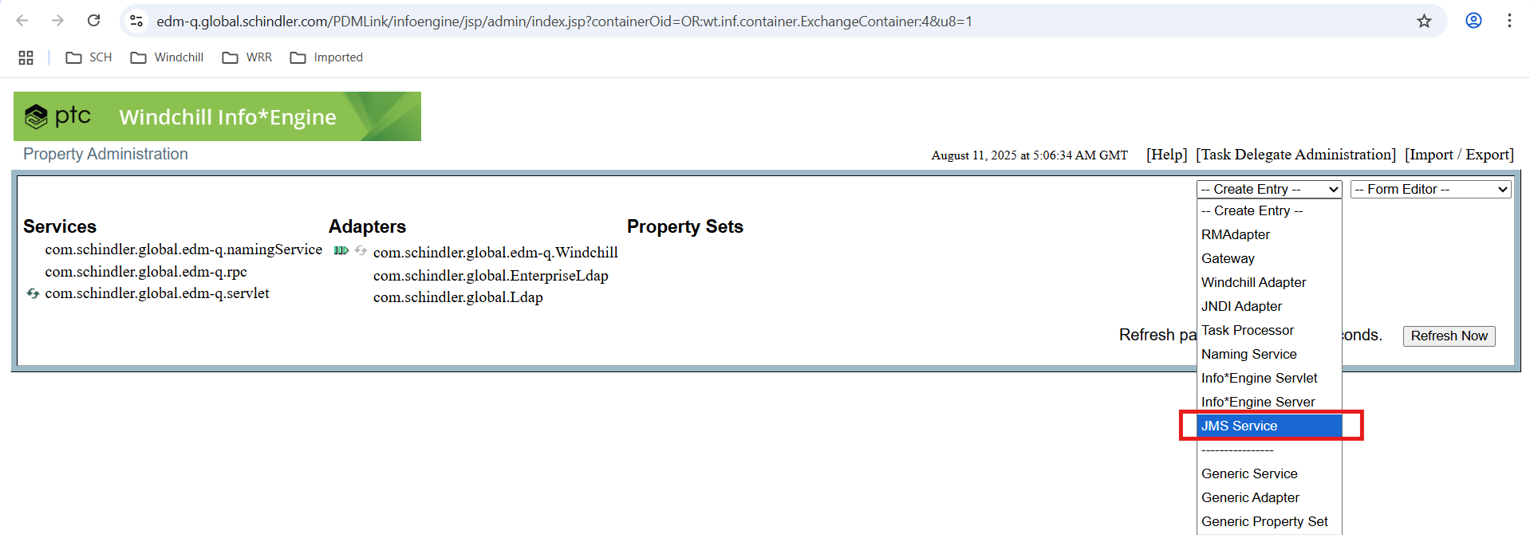

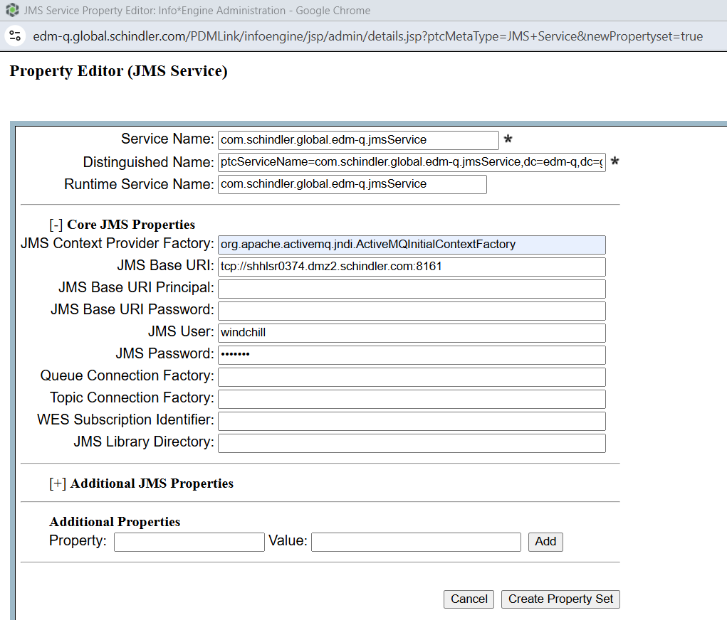

Refer below password for environment  
*Note: Please refer below table for values of JMS Base URI, username and password for each environment*

|  |  |  |  |
| --- | --- | --- | --- |
| Environment | Dev | QA | Prod |
| JMS Base URI | tcp://shhlsr0375.dmz2.schindler.com:8161 | tcp://shhlsr0374.dmz2.schindler.com:8161 | tcp://shhlsr0376.dmz2.schindler.com:8161 |
| JMS User | windchill | windchill | windchill |
| JMS Password | **<Password>** | **<Password>** | **<Password>** |

* Once Service is created then it will be available under Property Sets
* Click on created Property Set and validate values

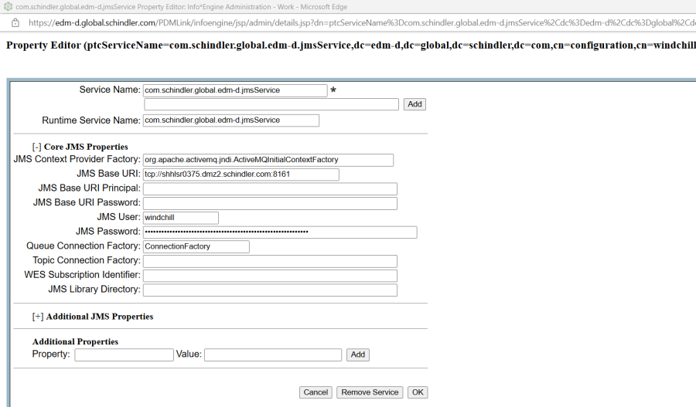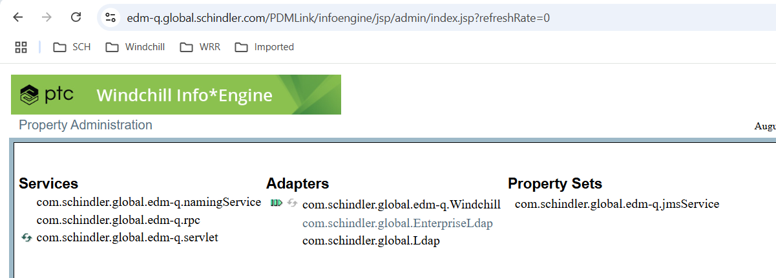

## Update SchindlerCMSArbortextPublishRules

* Navigate to CTA Library > Utilities > Visualization Configuration Administration

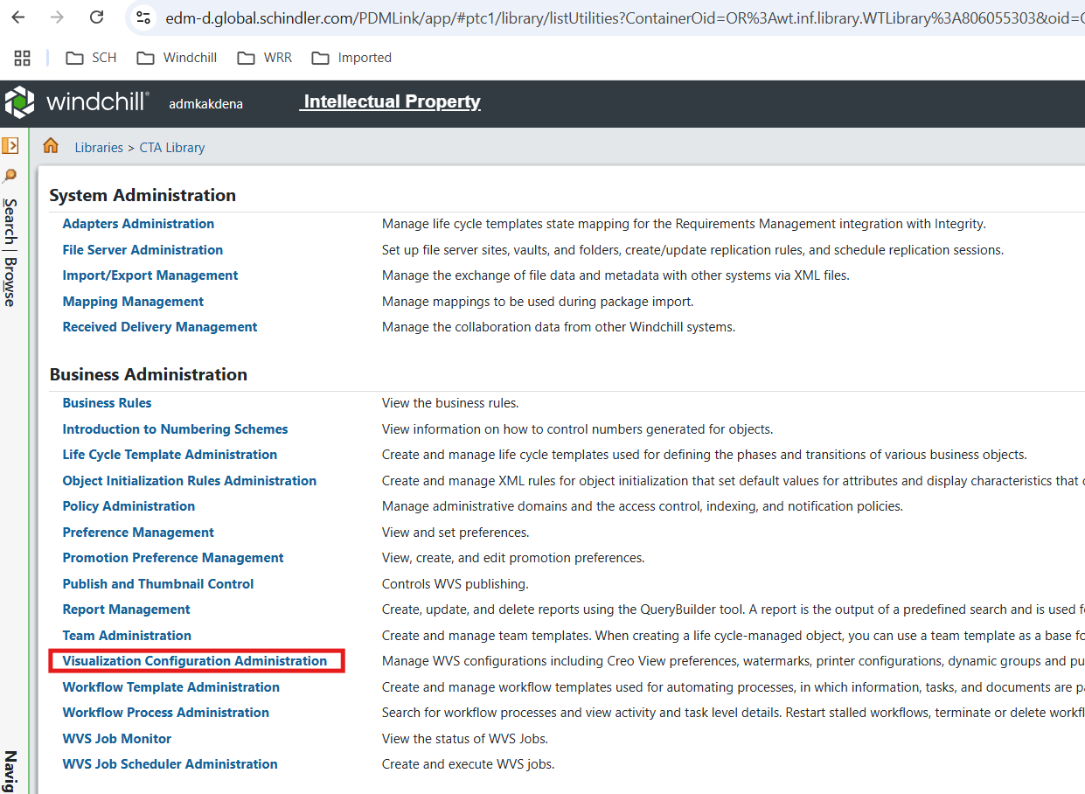

* Select CTA Library

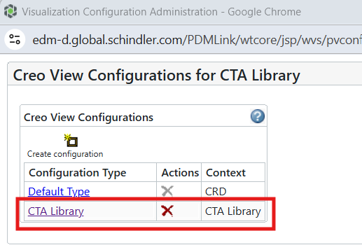

* Download updated SchindlerCMSArbortextPublishRules.xml from attachment

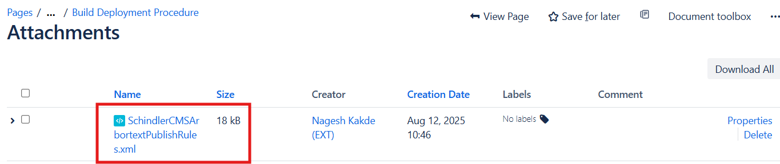

* Delete SchindlerCMSArbortextPublishRules.xml and add file downloaded in previous step

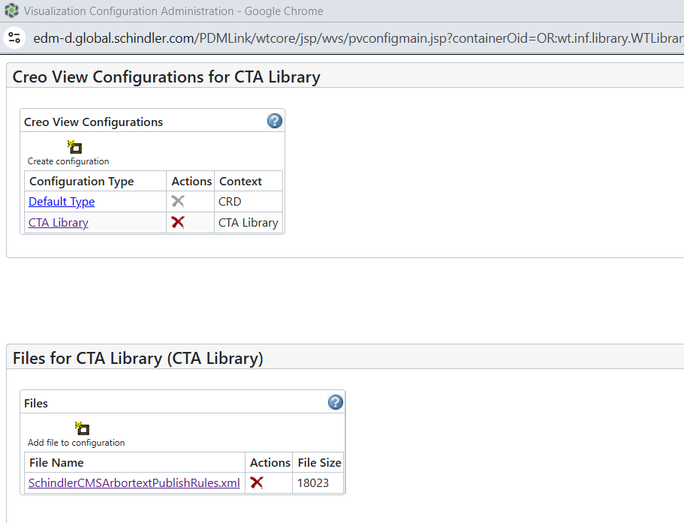

## Update SchindlerCMSArbortextPublishRules - SC7 Product

* Navigate to SC7 Product > Utilities > Visualization Configuration Administration

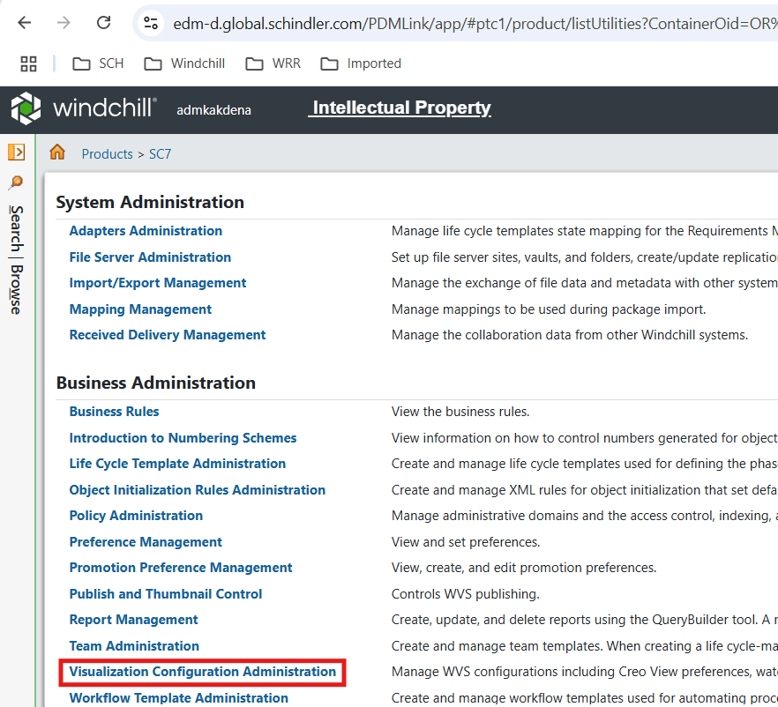

* Download updated SchindlerCMSArbortextPublishRules_SC7.xml from attachment

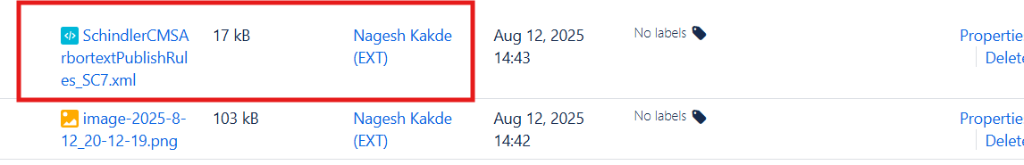

* Delete SchindlerCMSArbortextPublishRules.xml and add file downloaded in previous step after renaming to SchindlerCMSArbortextPublishRules

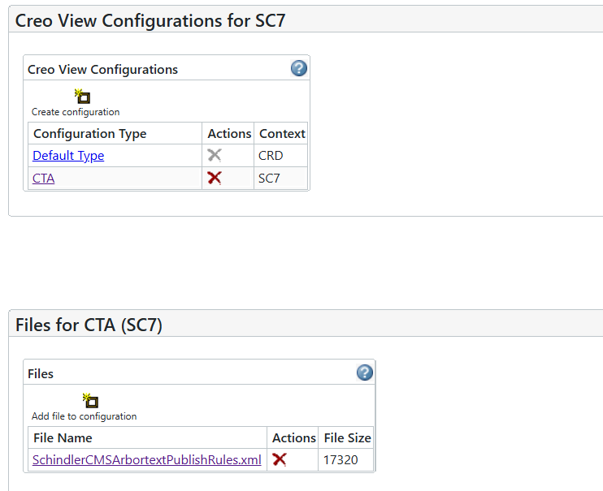

## Update SchindlerCMSTranslationPublishRules

* Navigate to CTA Translations Library > Utilities > Visualization Configuration Administration

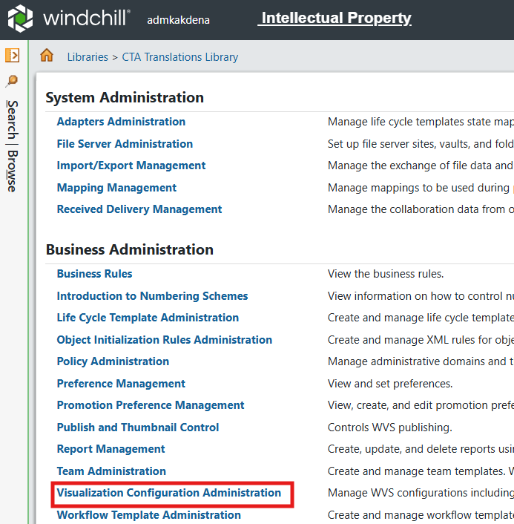

* Select CTA Translation Library

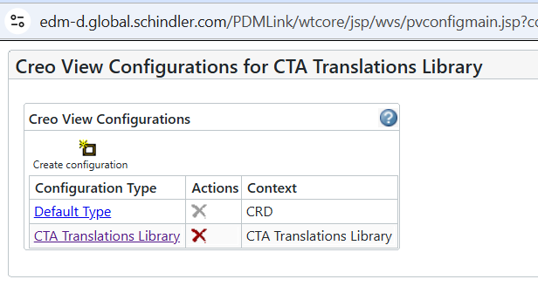

* Download updated SchindlerCMSArbortextPublishRules.xml from attachment



* Delete SchindlerCMSArbortextPublishRules.xml and add file downloaded in previous step

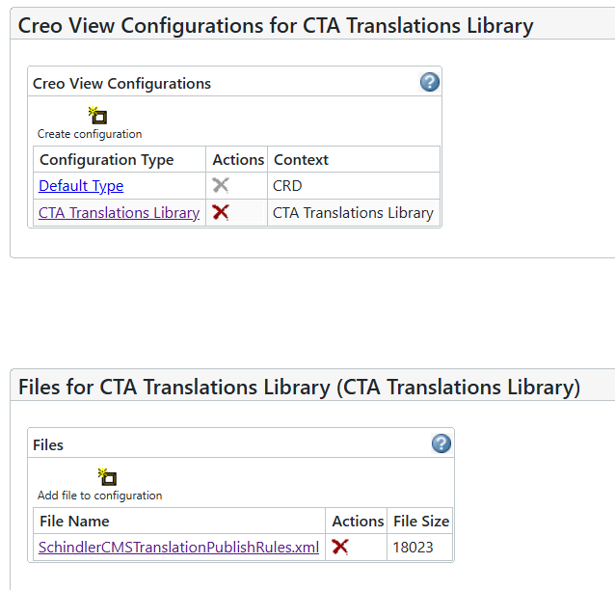

## Update Translation Preferences

1. Update *Translation Support* related preferences and make sure it is matching with source system.

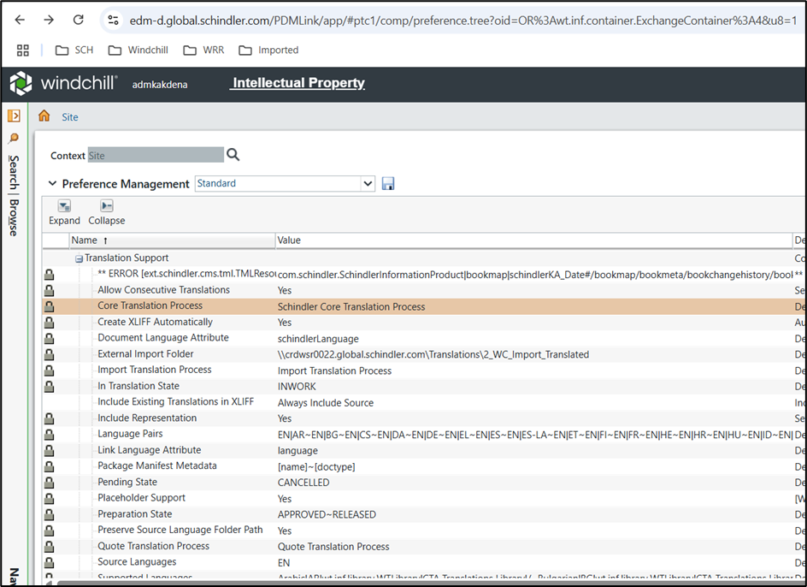

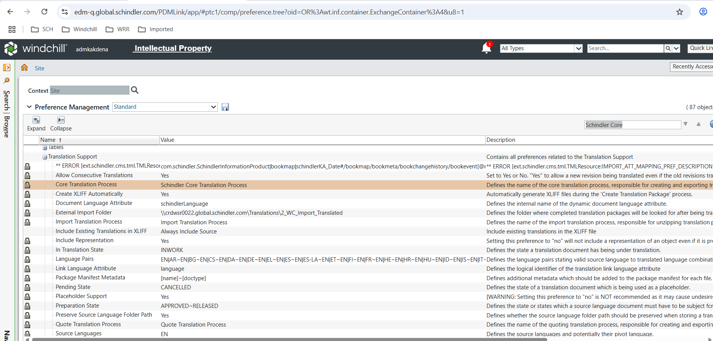

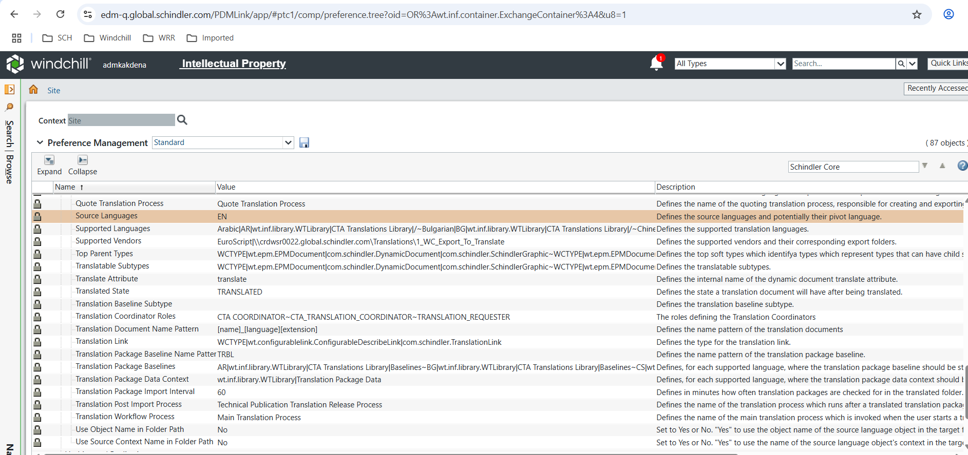

## Create AdHocAccessReport Task delegate

* Navigate to site > Utilities > Task Delegate Administration

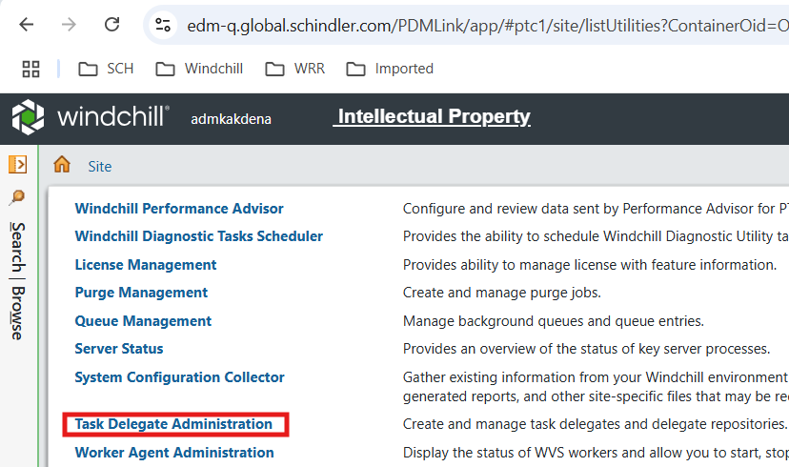

* Open Task Delegate Administration

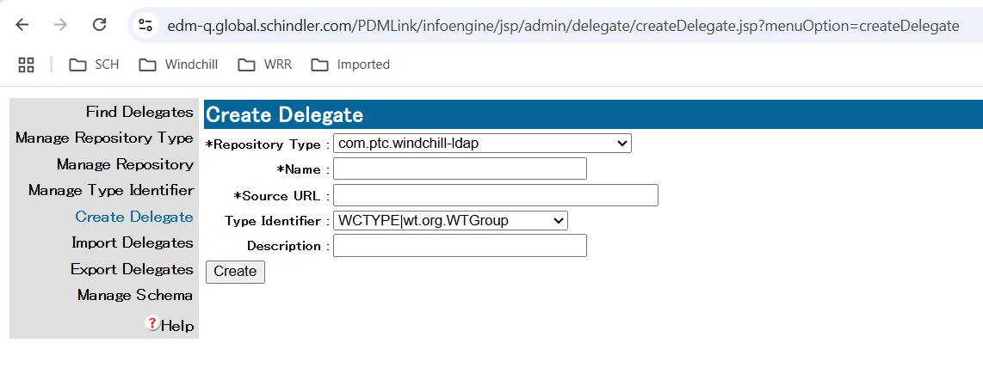

* Create AdHocAccessReport delegate with below details.
* Create AdHocAccessReport Task delegate

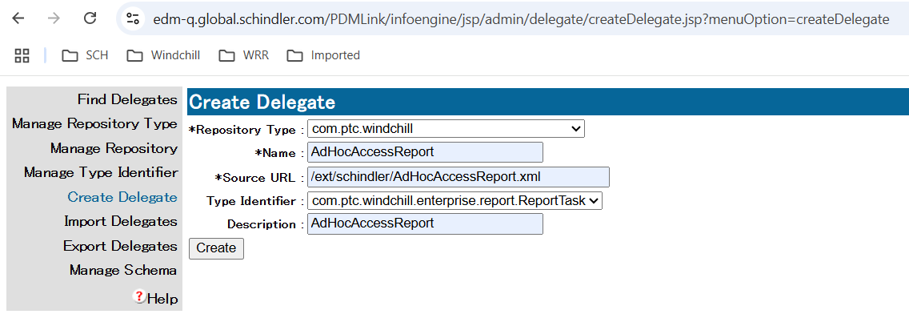

## Update Sync on CA Complete robot to use Object Event

* Edit Schindler Change Notice Workflow from Site > Utilities > Workflow Template Administration

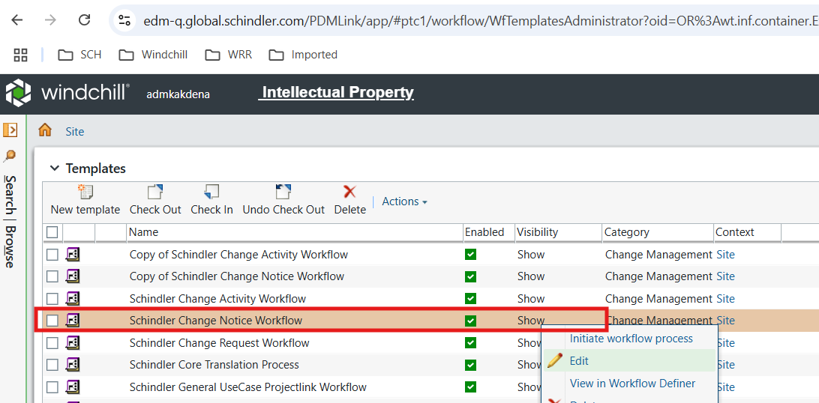

* Select Object Event in Sync on CA Complete

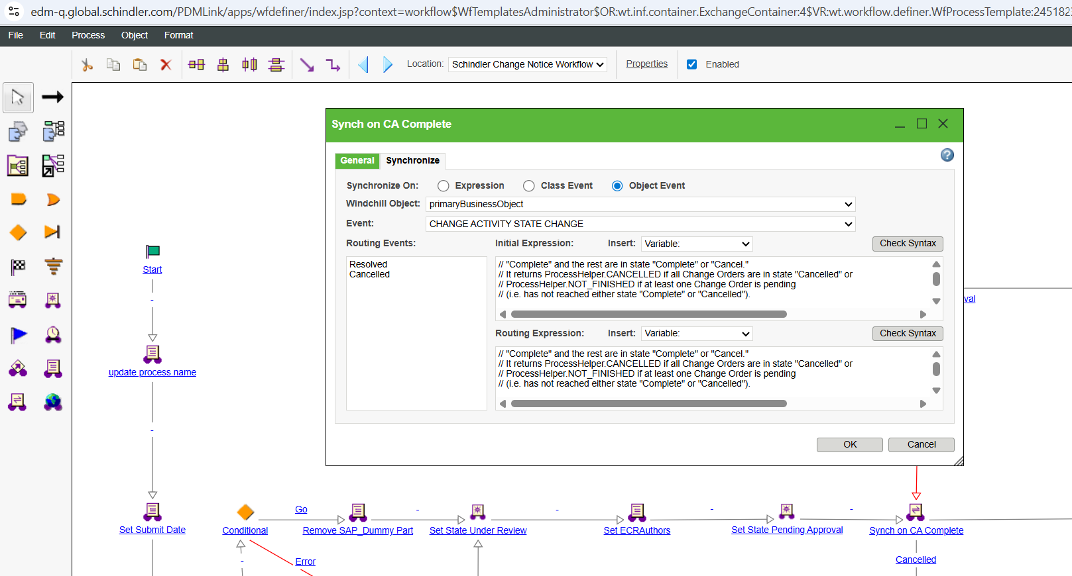

* Click on Check Syntax for initial Expression and Routing Expression.

